- Spring Data JPA - Quick Example
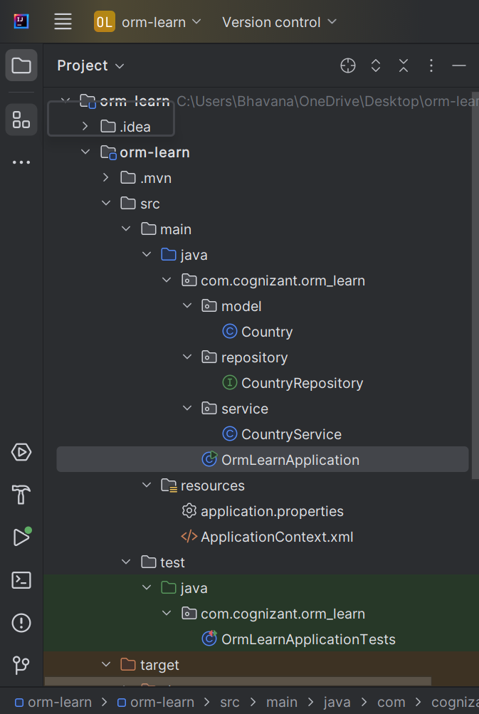

POM.XML
<?xml version="1.0" encoding="UTF-8"?>
<project xmlns="http://maven.apache.org/POM/4.0.0"
xmlns:xsi="http://www.w3.org/2001/XMLSchema-instance"
xsi:schemaLocation="http://maven.apache.org/POM/4.0.0 https://maven.apache.org/xsd/maven-4.0.0.xsd">
<modelVersion>4.0.0</modelVersion>
<parent>
<groupId>org.springframework.boot</groupId>
<artifactId>spring-boot-starter-parent</artifactId>
<version>3.5.3</version>
<relativePath/>
</parent>
<groupId>com.cognizant</groupId>
<artifactId>orm-learn</artifactId>
<version>0.0.1-SNAPSHOT</version>
<name>orm-learn</name>
<description>Project for Spring Data JPA and Hibernate</description>
<properties>
<java.version>17</java.version>
</properties>
<dependencies>
<dependency>
<groupId>org.springframework.boot</groupId>
<artifactId>spring-boot-starter-data-jpa</artifactId>
</dependency>
<dependency>
<groupId>org.springframework.boot</groupId>
<artifactId>spring-boot-starter-web</artifactId>
</dependency>
<dependency>
<groupId>com.mysql</groupId>
<artifactId>mysql-connector-j</artifactId>
<scope>runtime</scope>
</dependency>
<dependency>
<groupId>org.springframework.boot</groupId>
<artifactId>spring-boot-starter-test</artifactId>
<scope>test</scope>
</dependency>
</dependencies>
<build>
<plugins>
<plugin>
<groupId>org.springframework.boot</groupId>
<artifactId>spring-boot-maven-plugin</artifactId>
</plugin>
</plugins>
</build>
</project>

ApplicationContext.xml

<?xml version="1.0" encoding="UTF-8"?>
<beans xmlns="http://www.springframework.org/schema/beans"
xmlns:xsi="http://www.w3.org/2001/XMLSchema-instance"
xsi:schemaLocation="
http://www.springframework.org/schema/beans
http://www.springframework.org/schema/beans/spring-beans.xsd">
<!-- Repository Bean -->
<bean id="bookRepository" class="com.library.repository.BookRepository"/>
<bean id="bookService" class="com.library.service.BookService">
<property name="bookRepository" ref="bookRepository"/>
</bean>
</beans>

Application.properties
spring.datasource.driver-class-name=com.mysql.cj.jdbc.Driver
spring.datasource.url=jdbc:mysql://localhost:3306/ormlearn
spring.datasource.username=root
spring.datasource.password=Bhavana@1320
spring.jpa.hibernate.ddl-auto=validate
spring.jpa.properties.hibernate.dialect=org.hibernate.dialect.MySQLDialect
spring.jpa.show-sql=true

Country.java
package com.cognizant.orm_learn.model;
import jakarta.persistence.*;
@Entity
@Table(name = "country")
public class Country {
@Id
@Column(name = "code")
private String code;
@Column(name = "name")
private String name;
public String getCode() {
return code;
}
public void setCode(String code) {
this.code = code;
}
public String getName() {
return name;
}
public void setName(String name) {
this.name = name;
}
@Override
public String toString() {
return "Country [code=" + code + ", name=" + name + "]";
}
}

CountryRepository.java
package com.cognizant.orm_learn.repository;
import org.springframework.data.jpa.repository.JpaRepository;
import org.springframework.stereotype.Repository;
import com.cognizant.orm_learn.model.Country;
@Repository
public interface CountryRepository extends JpaRepository<Country, String> {
}

CountryService.java
package com.cognizant.orm_learn.service;
import java.util.List;
import org.springframework.beans.factory.annotation.Autowired;
import org.springframework.stereotype.Service;
import org.springframework.transaction.annotation.Transactional;
import com.cognizant.orm_learn.model.Country;
import com.cognizant.orm_learn.repository.CountryRepository;
@Service
public class CountryService {
@Autowired
private CountryRepository countryRepository;
@Transactional
public List<Country> getAllCountries() {
return countryRepository.findAll();
}
}

OrmLearnApplication.java
package com.cognizant.orm_learn;
import java.util.List;
import org.slf4j.Logger;
import org.slf4j.LoggerFactory;
import org.springframework.boot.SpringApplication;
import org.springframework.boot.autoconfigure.SpringBootApplication;
import org.springframework.context.ApplicationContext;
import com.cognizant.orm_learn.model.Country;
import com.cognizant.orm_learn.service.CountryService;
@SpringBootApplication
public class OrmLearnApplication {
private static final Logger LOGGER =
LoggerFactory.getLogger(OrmLearnApplication.class);
private static CountryService countryService;
public static void main(String[] args) {
ApplicationContext context =
SpringApplication.run(OrmLearnApplication.class, args);
LOGGER.info("Inside main");
countryService = context.getBean(CountryService.class);
testGetAllCountries();
}
private static void testGetAllCountries() {
LOGGER.info("Start");
List<Country> countries = countryService.getAllCountries();
LOGGER.debug("countries={}", countries);
LOGGER.info("End");
}
}

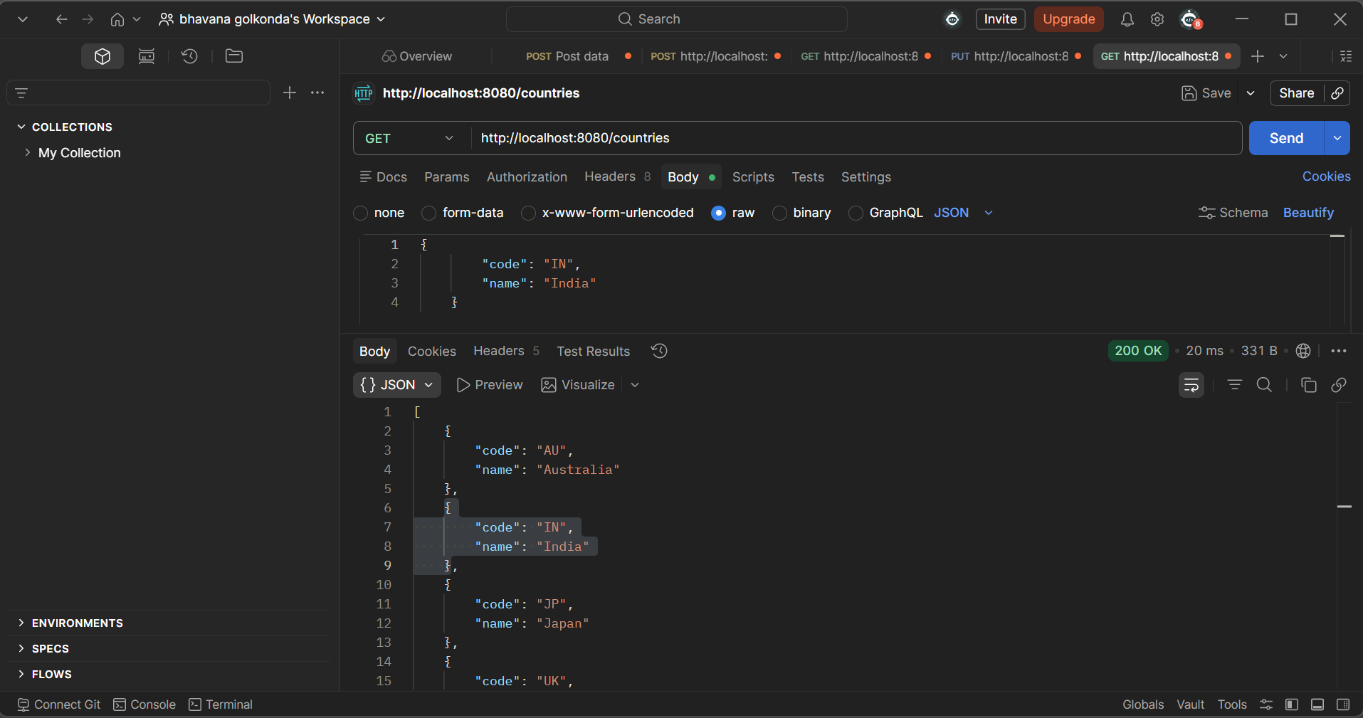

- Difference Between JPA, Hibernate, and Spring Data JPA
1. Java Persistence API (JPA)
- A specification (JSR 338) that defines how Java objects interact with relational databases.
- Provides a set of interfaces and annotations for ORM.
- Does not provide an implementation — needs a provider like Hibernate, EclipseLink, etc.
2. Hibernate
- A popular ORM (Object-Relational Mapping) framework.
- Provides a concrete implementation of the JPA specification.
- Also includes additional features beyond JPA (e.g., native SQL, custom caching).
- Developers often write boilerplate code to manage sessions, transactions, etc.

3. Spring Data JPA
- A wrapper/abstraction over JPA providers like Hibernate.
- Eliminates boilerplate code for DAO layers.
- Provides built-in repository interfaces (like JpaRepository, CrudRepository).
- Handles transactions automatically via Spring’s @Transactional.
- Promotes clean, readable, and maintainable code.

Hibernate vs Spring Data JPA
Hibernate:
public Integer addEmployee(Employee employee) {
Session session = factory.openSession();
Transaction tx = null;
Integer employeeID = null;

try {

tx = session.beginTransaction();
employeeID = (Integer) session.save(employee);
tx.commit();
}
catch (HibernateException e) {
if (tx != null) tx.rollback();
e.printStackTrace();
}
finally {
session.close();
}
return employeeID;
}

Spring Data JPA
EmployeeRepository.java
public interface EmployeeRepository extends JpaRepository<Employee, Integer> {
}
EmployeeService.java
@Service
public class EmployeeService {
@Autowired
private EmployeeRepository employeeRepository;
@Transactional
public void addEmployee(Employee employee) {
employeeRepository.save(employee);
}
}
Benefits:
- No need to write boilerplate code.
- Built-in CRUD methods like save(), findById(), deleteById().
- Automatically integrates with Spring’s transaction management.

Additional Important handson

Implement services for managing Country
Folder Structure:
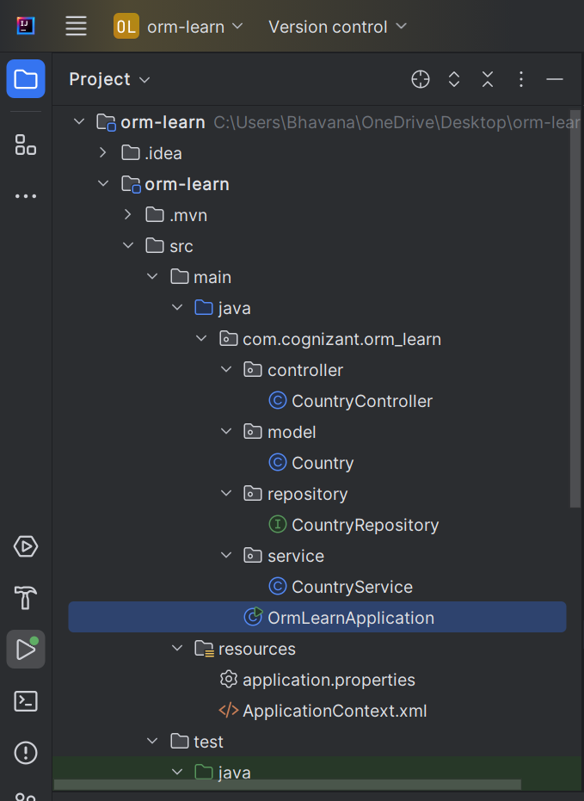

POM.XML
<?xml version="1.0" encoding="UTF-8"?>
<project xmlns="http://maven.apache.org/POM/4.0.0"
xmlns:xsi="http://www.w3.org/2001/XMLSchema-instance"
xsi:schemaLocation="http://maven.apache.org/POM/4.0.0 https://maven.apache.org/xsd/maven-4.0.0.xsd">
<modelVersion>4.0.0</modelVersion>
<parent>
<groupId>org.springframework.boot</groupId>
<artifactId>spring-boot-starter-parent</artifactId>
<version>3.5.3</version>
<relativePath/>
</parent>
<groupId>com.cognizant</groupId>
<artifactId>orm-learn</artifactId>
<version>0.0.1-SNAPSHOT</version>
<name>orm-learn</name>
<description>Project for Spring Data JPA and Hibernate</description>
<properties>
<java.version>17</java.version>
</properties>
<dependencies>
<dependency>
<groupId>org.springframework.boot</groupId>
<artifactId>spring-boot-starter-data-jpa</artifactId>
</dependency>
<dependency>
<groupId>org.springframework.boot</groupId>
<artifactId>spring-boot-starter-web</artifactId>
</dependency>
<dependency>
<groupId>com.mysql</groupId>
<artifactId>mysql-connector-j</artifactId>
<scope>runtime</scope>
</dependency>
<dependency>
<groupId>org.springframework.boot</groupId>
<artifactId>spring-boot-starter-test</artifactId>
<scope>test</scope>
</dependency>
</dependencies>
<build>
<plugins>
<plugin>
<groupId>org.springframework.boot</groupId>
<artifactId>spring-boot-maven-plugin</artifactId>
</plugin>
</plugins>
</build>
</project>

ApplicationContext.xml

<?xml version="1.0" encoding="UTF-8"?>
<beans xmlns="http://www.springframework.org/schema/beans"
xmlns:xsi="http://www.w3.org/2001/XMLSchema-instance"
xsi:schemaLocation="
http://www.springframework.org/schema/beans
http://www.springframework.org/schema/beans/spring-beans.xsd">
<!-- Repository Bean -->
<bean id="bookRepository" class="com.library.repository.BookRepository"/>
<bean id="bookService" class="com.library.service.BookService">
<property name="bookRepository" ref="bookRepository"/>
</bean>
</beans>

Application.properties
spring.datasource.driver-class-name=com.mysql.cj.jdbc.Driver
spring.datasource.url=jdbc:mysql://localhost:3306/ormlearn
spring.datasource.username=root
spring.datasource.password=Bhavana@1320
spring.jpa.hibernate.ddl-auto=validate
spring.jpa.properties.hibernate.dialect=org.hibernate.dialect.MySQLDialect
spring.jpa.show-sql=true

Country.java
package com.cognizant.orm_learn.model;
import jakarta.persistence.*;
@Entity
@Table(name = "country")
public class Country {
@Id
@Column(name = "code")
private String code;
@Column(name = "name")
private String name;
public String getCode() {
return code;
}
public void setCode(String code) {
this.code = code;
}
public String getName() {
return name;
}
public void setName(String name) {
this.name = name;
}
@Override
public String toString() {
return "Country [code=" + code + ", name=" + name + "]";
}
}

CountryRepository.java
package com.cognizant.orm_learn.repository;
import org.springframework.data.jpa.repository.JpaRepository;
import org.springframework.stereotype.Repository;
import com.cognizant.orm_learn.model.Country;
@Repository
public interface CountryRepository extends JpaRepository<Country, String> {
}

CountryService.java
package com.cognizant.orm_learn.service;
import java.util.List;
import org.springframework.beans.factory.annotation.Autowired;
import org.springframework.stereotype.Service;
import org.springframework.transaction.annotation.Transactional;
import com.cognizant.orm_learn.model.Country;
import com.cognizant.orm_learn.repository.CountryRepository;
@Service
public class CountryService {
@Autowired
private CountryRepository countryRepository;
@Transactional
public List<Country> getAllCountries() {
return countryRepository.findAll();
}
}
CountryController.java
package com.cognizant.orm_learn.controller;
import com.cognizant.orm_learn.model.Country;
import com.cognizant.orm_learn.service.CountryService;
import org.springframework.beans.factory.annotation.Autowired;
import org.springframework.web.bind.annotation.*;
import java.util.List;
@RestController
@RequestMapping("/countries")
public class CountryController {
@Autowired
private CountryService service;
@GetMapping
public List<Country> getAllCountries() {
return service.getAllCountries();
}
}

OrmLearnApplication.java
package com.cognizant.orm_learn;
import java.util.List;
import org.slf4j.Logger;
import org.slf4j.LoggerFactory;
import org.springframework.boot.SpringApplication;
import org.springframework.boot.autoconfigure.SpringBootApplication;
import org.springframework.context.ApplicationContext;
import com.cognizant.orm_learn.model.Country;
import com.cognizant.orm_learn.service.CountryService;
@SpringBootApplication
public class OrmLearnApplication {
private static final Logger LOGGER =
LoggerFactory.getLogger(OrmLearnApplication.class);
private static CountryService countryService;
public static void main(String[] args) {
ApplicationContext context =
SpringApplication.run(OrmLearnApplication.class, args);
LOGGER.info("Inside main");
countryService = context.getBean(CountryService.class);
testGetAllCountries();
}
private static void testGetAllCountries() {
LOGGER.info("Start");
List<Country> countries = countryService.getAllCountries();
LOGGER.debug("countries={}", countries);
LOGGER.info("End");
}
}

Testing using postman

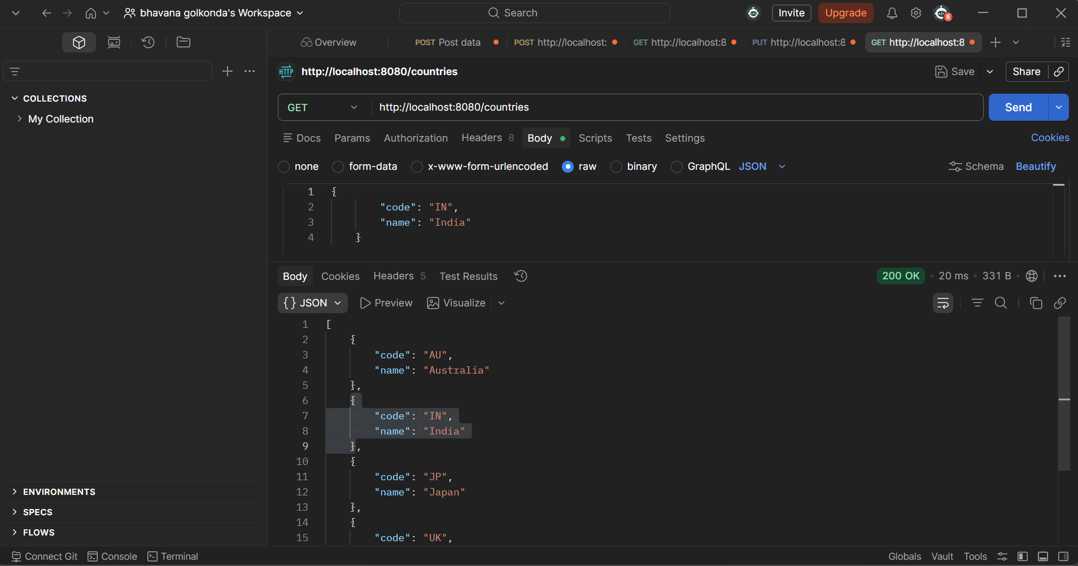

Find a country based on country code:
Folder structure
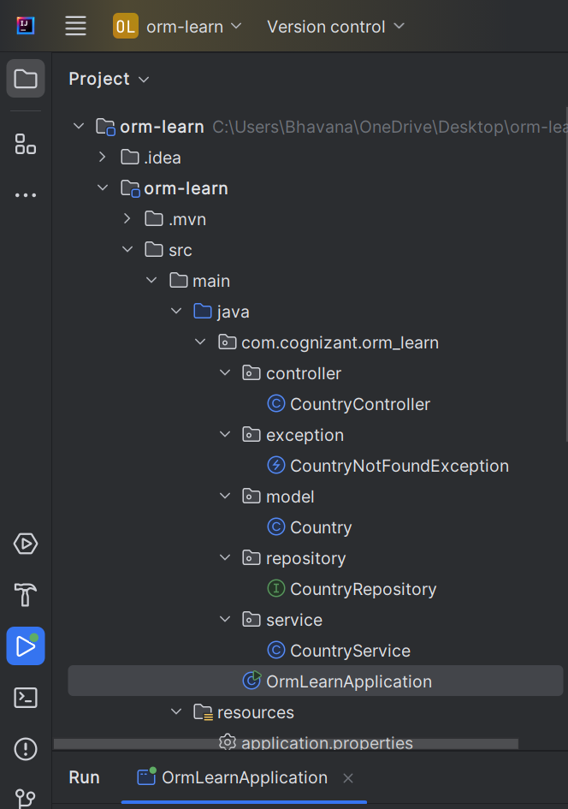

Country.java
package com.cognizant.orm_learn.model;
import jakarta.persistence.*;
@Entity
@Table(name = "country")
public class Country {
@Id
@Column(name = "code")
private String code;
@Column(name = "name")
private String name;
public String getCode() {
return code;
}
public void setCode(String code) {
this.code = code;
}
public String getName() {
return name;
}
public void setName(String name) {
this.name = name;
}
@Override
public String toString() {
return "Country [code=" + code + ", name=" + name + "]";
}
}

CountryRepository.java

package com.cognizant.orm_learn.repository;
import org.springframework.data.jpa.repository.JpaRepository;
import org.springframework.stereotype.Repository;
import com.cognizant.orm_learn.model.Country;
@Repository
public interface CountryRepository extends JpaRepository<Country, String> {
}

CountryService.java

package com.cognizant.orm_learn.service;
import java.util.List;
import java.util.Optional;
import org.springframework.beans.factory.annotation.Autowired;
import org.springframework.stereotype.Service;
import org.springframework.transaction.annotation.Transactional;
import com.cognizant.orm_learn.model.Country;
import com.cognizant.orm_learn.repository.CountryRepository;
import com.cognizant.orm_learn.exception.CountryNotFoundException;
@Service
public class CountryService {
@Autowired
private CountryRepository countryRepository;
@Transactional
public List<Country> getAllCountries() {
return countryRepository.findAll();
}
@Transactional
public Country findCountryByCode(String code) {
Optional<Country> result = countryRepository.findById(code);
if (!result.isPresent()) {
throw new CountryNotFoundException("Country not found: " + code);
}
return result.get();
}
}

CountryController.java
package com.cognizant.orm_learn.controller;
import com.cognizant.orm_learn.model.Country;
import com.cognizant.orm_learn.service.CountryService;
import org.springframework.beans.factory.annotation.Autowired;
import org.springframework.web.bind.annotation.*;
import java.util.List;
@RestController
@RequestMapping("/countries")
public class CountryController {
@Autowired
private CountryService service;
@GetMapping
public List<Country> getAllCountries() {
return service.getAllCountries();
}
@GetMapping("/{code}")
public Country getCountryByCode(@PathVariable String code) {
return service.findCountryByCode(code);
}
}

CountryNotfoundException.java

package com.cognizant.orm_learn.exception;
public class CountryNotFoundException extends RuntimeException {
public CountryNotFoundException(String message) {
super(message);
}
}

OUTPUT:

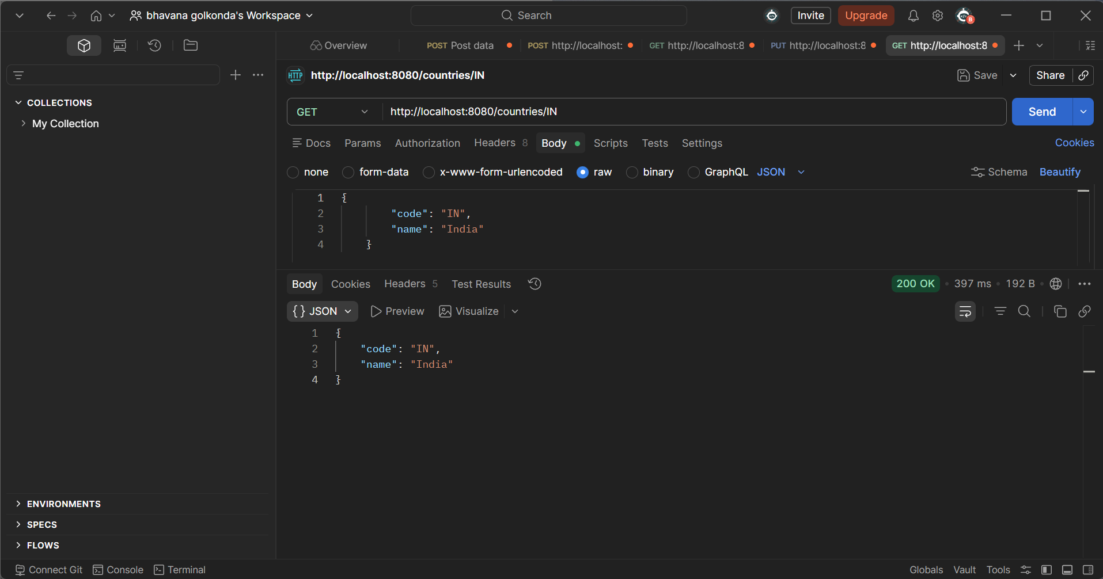

ADD A NEW COUNTRY

CountryService.java

package com.cognizant.orm_learn.service;
import java.util.List;
import java.util.Optional;
import org.springframework.beans.factory.annotation.Autowired;
import org.springframework.stereotype.Service;
import org.springframework.transaction.annotation.Transactional;
import com.cognizant.orm_learn.model.Country;
import com.cognizant.orm_learn.repository.CountryRepository;
import com.cognizant.orm_learn.exception.CountryNotFoundException;
@Service
public class CountryService {
@Autowired
private CountryRepository countryRepository;
@Transactional
public List<Country> getAllCountries() {
return countryRepository.findAll();
}
@Transactional
public Country findCountryByCode(String code) {
Optional<Country> result = countryRepository.findById(code);
if (!result.isPresent()) {
throw new CountryNotFoundException("Country not found: " + code);
}
return result.get();
}
@Transactional
public void addCountry(Country country) {
countryRepository.save(country);
}
}

CountryRepository.java

package com.cognizant.orm_learn.repository;
import org.springframework.data.jpa.repository.JpaRepository;
import org.springframework.stereotype.Repository;
import com.cognizant.orm_learn.model.Country;
@Repository
public interface CountryRepository extends JpaRepository<Country, String> {
}
Country.java

package com.cognizant.orm_learn.model;
import jakarta.persistence.*;
@Entity
@Table(name = "country")
public class Country {
@Id
@Column(name = "code")
private String code;
@Column(name = "name")
private String name;
public String getCode() {
return code;
}
public void setCode(String code) {
this.code = code;
}
public String getName() {
return name;
}
public void setName(String name) {
this.name = name;
}
@Override
public String toString() {
return "Country [code=" + code + ", name=" + name + "]";
}
}

CountryController.java

package com.cognizant.orm_learn.controller;
import com.cognizant.orm_learn.model.Country;
import com.cognizant.orm_learn.service.CountryService;
import org.springframework.beans.factory.annotation.Autowired;
import org.springframework.web.bind.annotation.*;
import java.util.List;
@RestController
@RequestMapping("/countries")
public class CountryController {
@Autowired
private CountryService service;
@GetMapping
public List<Country> getAllCountries() {
return service.getAllCountries();
}
@GetMapping("/{code}")
public Country getCountryByCode(@PathVariable String code) {
return service.findCountryByCode(code);
}
@PostMapping
public String addCountry(@RequestBody Country country) {
service.addCountry(country);
return "Country added successfully!";
}
}

OrmLearnApplication.java

package com.cognizant.orm_learn;
import java.util.List;
import org.slf4j.Logger;
import org.slf4j.LoggerFactory;
import org.springframework.boot.SpringApplication;
import org.springframework.boot.autoconfigure.SpringBootApplication;
import org.springframework.context.ApplicationContext;
import com.cognizant.orm_learn.model.Country;
import com.cognizant.orm_learn.service.CountryService;
@SpringBootApplication
public class OrmLearnApplication {
private static final Logger LOGGER =
LoggerFactory.getLogger(OrmLearnApplication.class);
private static CountryService countryService;
public static void main(String[] args) {
ApplicationContext context =
SpringApplication.run(OrmLearnApplication.class, args);
LOGGER.info("Inside main");
countryService = context.getBean(CountryService.class);
testGetAllCountries();
}
private static void testGetAllCountries() {
LOGGER.info("Start");
List<Country> countries = countryService.getAllCountries();
LOGGER.debug("countries={}", countries);
LOGGER.info("End");
}
}

OUTPUT:

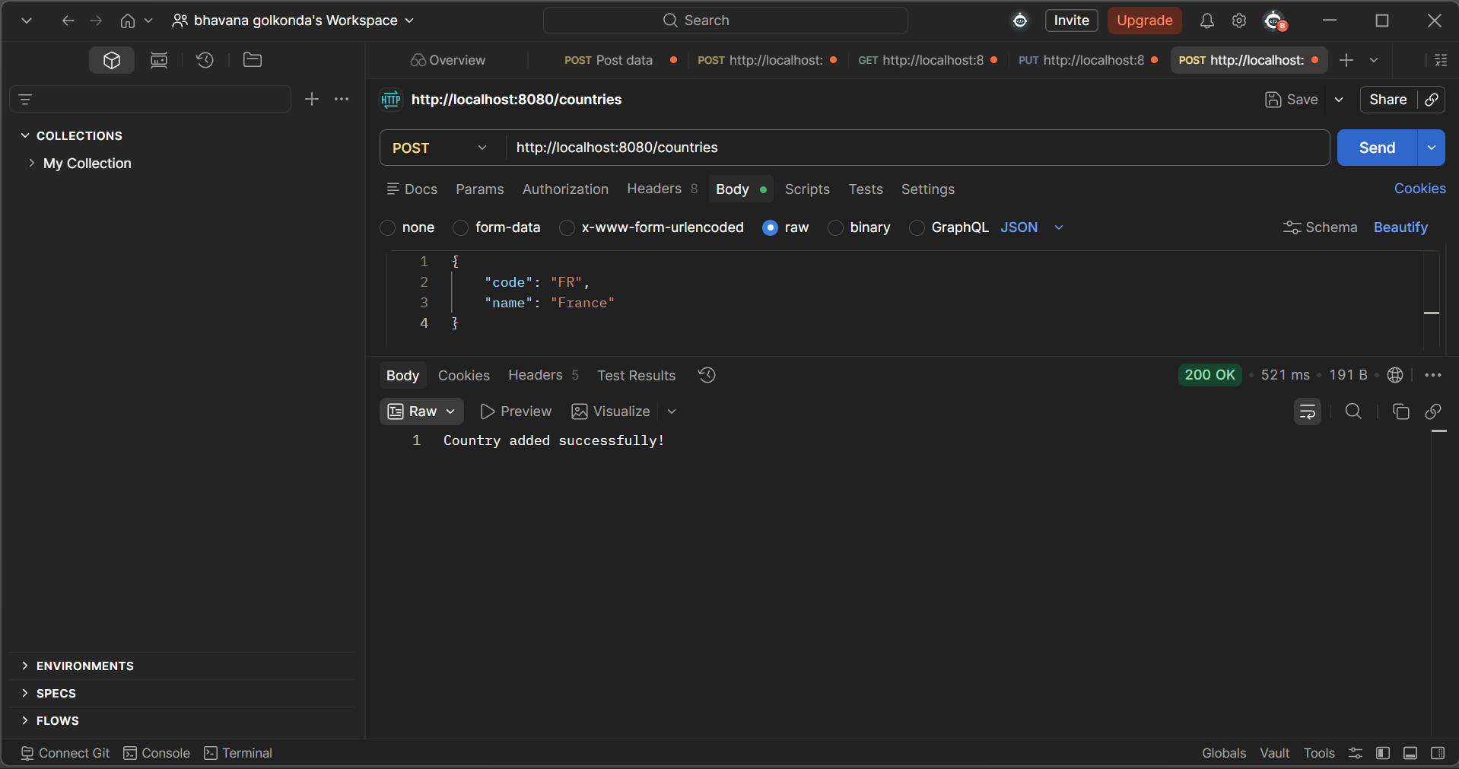

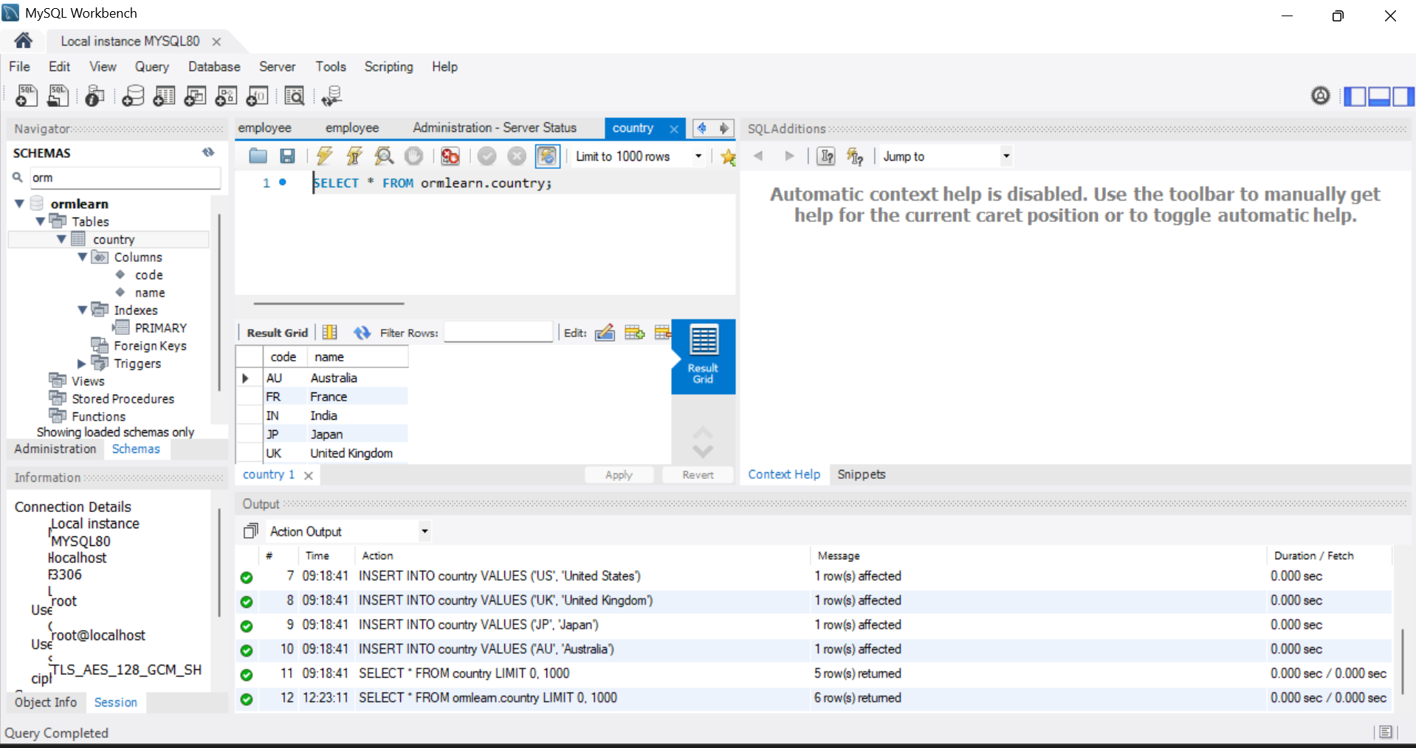

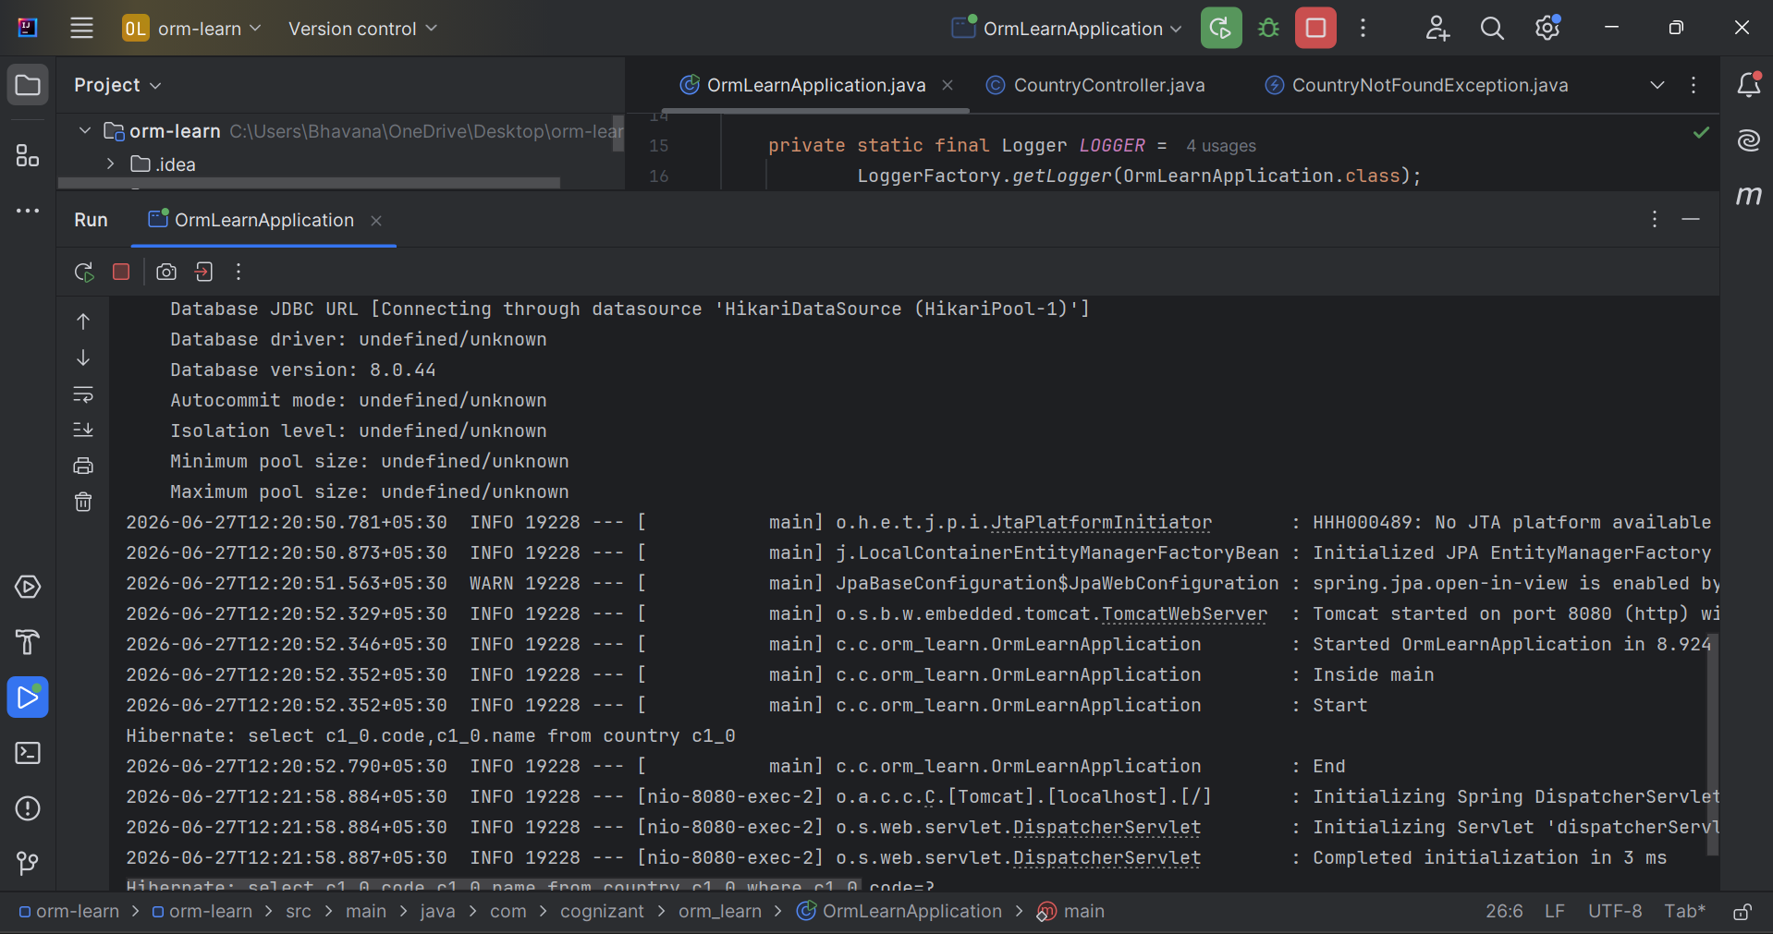

Demonstrate implementation of Query Methods feature of Spring Data JPA

Country.java

package com.cognizant.orm_learn.model;
import jakarta.persistence.*;
@Entity
@Table(name = "country")
public class Country {
@Id
@Column(name = "code")
private String code;
@Column(name = "name")
private String name;
public String getCode() {
return code;
}
public void setCode(String code) {
this.code = code;
}
public String getName() {
return name;
}
public void setName(String name) {
this.name = name;
}
@Override
public String toString() {
return "Country [code=" + code + ", name=" + name + "]";
}
}

CountryController.java

package com.cognizant.orm_learn.controller;
import com.cognizant.orm_learn.model.Country;
import com.cognizant.orm_learn.service.CountryService;
import org.springframework.beans.factory.annotation.Autowired;
import org.springframework.web.bind.annotation.*;
import java.util.List;
@RestController
@RequestMapping("/countries")
public class CountryController {
@Autowired
private CountryService service;
@GetMapping
public List<Country> getAllCountries() {
return service.getAllCountries();
}
@GetMapping("/{code}")
public Country getCountryByCode(@PathVariable String code) {
return service.findCountryByCode(code);
}
@PostMapping
public String addCountry(@RequestBody Country country) {
service.addCountry(country);
return "Country added successfully!";
}
@GetMapping("/search")
public List<Country> searchByName(@RequestParam String name) {
return service.searchCountries(name);
}
@GetMapping("/starts-with")
public List<Country> getByPrefix(@RequestParam String prefix) {
return service.getCountriesStartingWith(prefix);
}
@GetMapping("/top3")
public List<Country> getTop3() {
return service.getTop3Countries();
}
}

CountryService.java

package com.cognizant.orm_learn.service;
import java.util.List;
import java.util.Optional;
import org.springframework.beans.factory.annotation.Autowired;
import org.springframework.stereotype.Service;
import org.springframework.transaction.annotation.Transactional;
import com.cognizant.orm_learn.model.Country;
import com.cognizant.orm_learn.repository.CountryRepository;
import com.cognizant.orm_learn.exception.CountryNotFoundException;
@Service
public class CountryService {
@Autowired
private CountryRepository countryRepository;
@Transactional
public List<Country> getAllCountries() {
return countryRepository.findAll();
}
@Transactional
public Country findCountryByCode(String code) {
Optional<Country> result = countryRepository.findById(code);
if (!result.isPresent()) {
throw new CountryNotFoundException("Country not found: " + code);
}
return result.get();
}
@Transactional
public void addCountry(Country country) {
countryRepository.save(country);
}
public List<Country> searchCountries(String name) {
return countryRepository.findByNameContainingIgnoreCase(name);
}
public List<Country> getCountriesStartingWith(String prefix) {
return countryRepository.findByNameStartingWith(prefix);
}
public List<Country> getTop3Countries() {
return countryRepository.findTop3ByOrderByNameAsc();
}
}

CountryRepository.java

package com.cognizant.orm_learn.repository;
import org.springframework.data.jpa.repository.JpaRepository;
import org.springframework.stereotype.Repository;
import com.cognizant.orm_learn.model.Country;
import java.util.List;
@Repository
public interface CountryRepository extends JpaRepository<Country, String> {
List<Country> findByNameContainingIgnoreCase(String name);
List<Country> findByNameStartingWith(String prefix);
List<Country> findTop3ByOrderByNameAsc();
}

OUTPUT:
1.Search By Name:
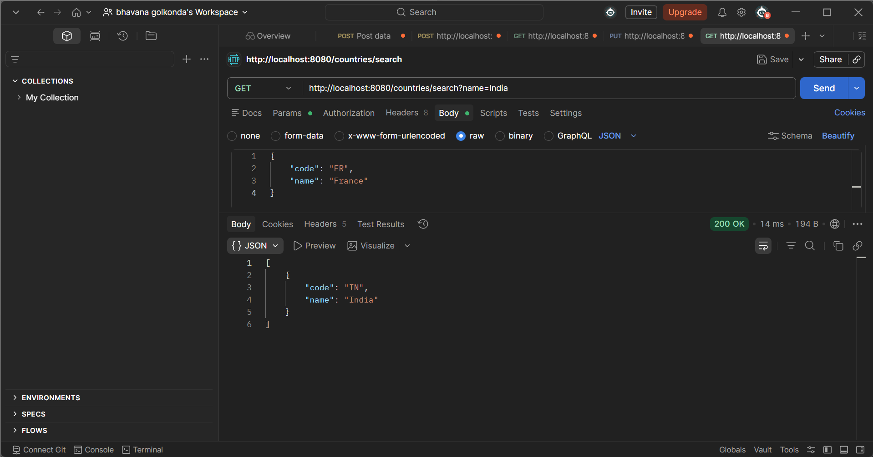

2.StartsWith:

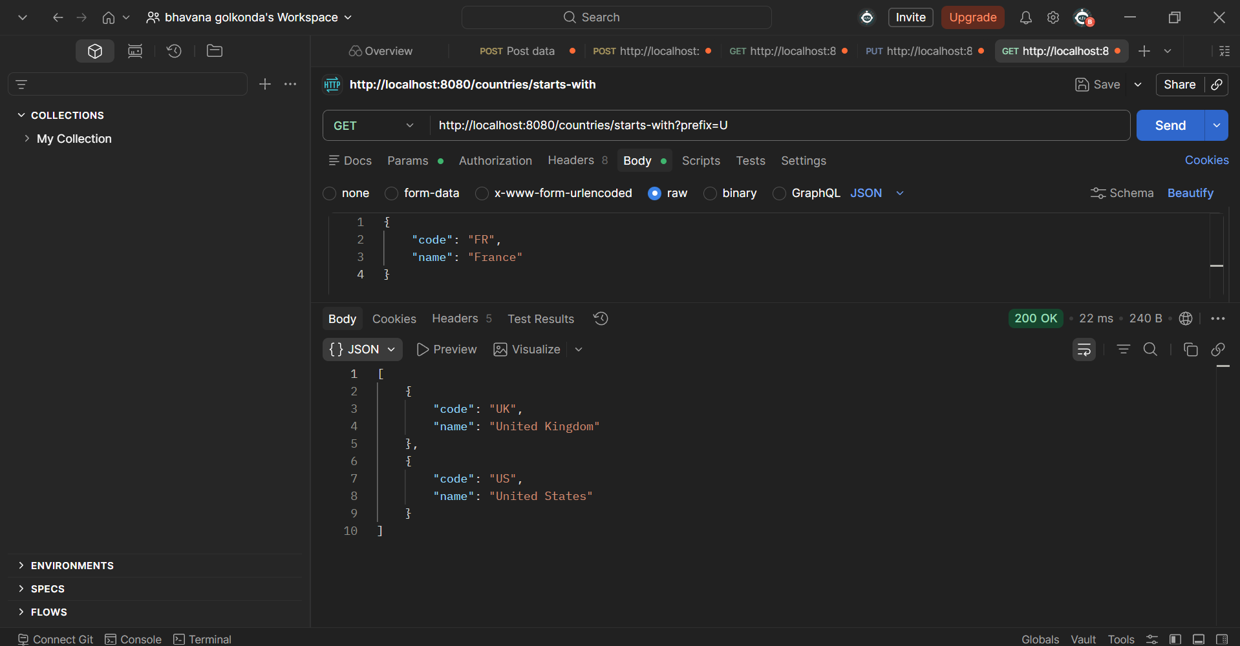

3.Top 3 Alphabetically:

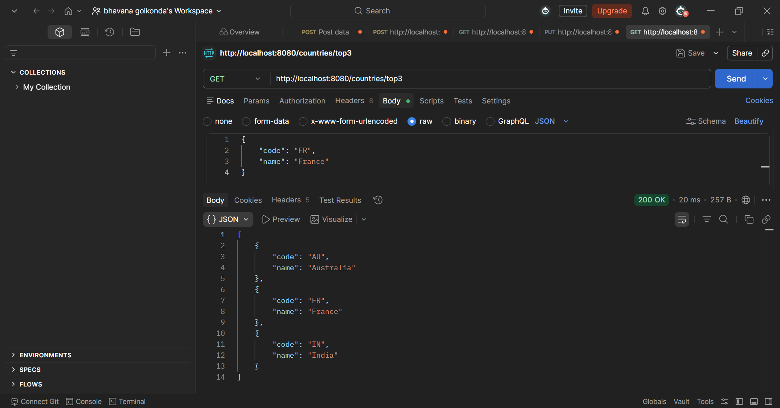

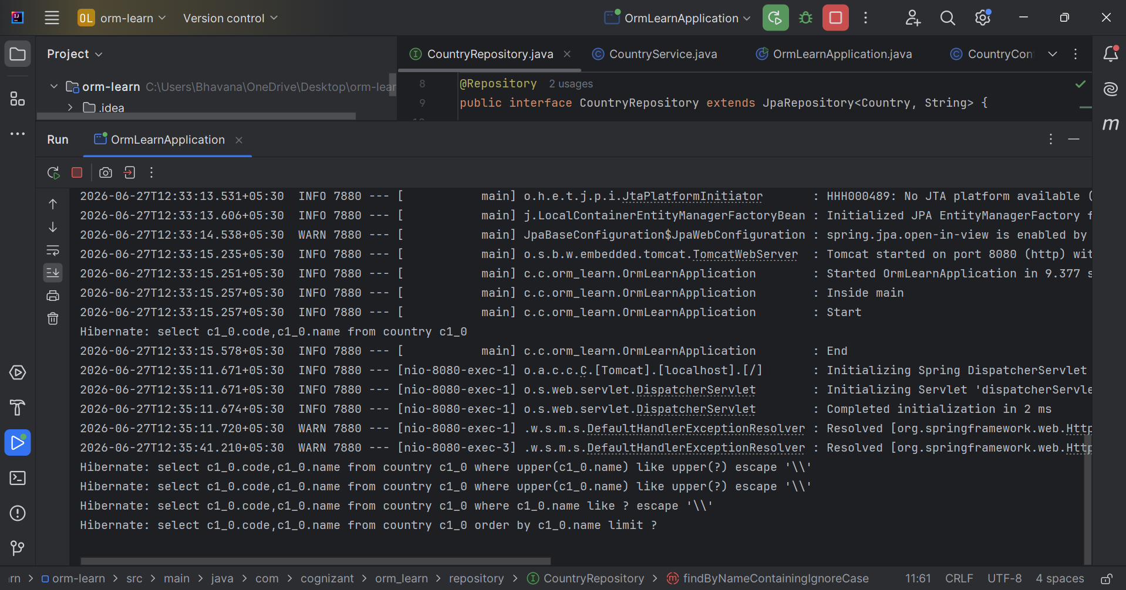

Demonstrate implementation of O/R Mapping

Employee.java

package com.example.ormlearn.model;
import jakarta.persistence.*;
import java.util.Date;
import java.util.List;
@Entity
@Table(name = "employee")
public class Employee {
@Id
@GeneratedValue(strategy = GenerationType.IDENTITY)
private int id;
private String name;
private double salary;
@Temporal(TemporalType.DATE)
@Column(name = "date_of_birth")
private Date dateOfBirth;
@ManyToOne(fetch = FetchType.EAGER)
@JoinColumn(name = "department_id")
private Department department;
@ManyToMany(fetch = FetchType.LAZY)
@JoinTable(
name = "employee_skill",
joinColumns = @JoinColumn(name = "employee_id"),
inverseJoinColumns = @JoinColumn(name = "skill_id")
)
private List<Skill> skills;
public int getId() {
return id;
}
public void setId(int id) {
this.id = id;
}
public String getName() {
return name;
}
public void setName(String name) {
this.name = name;
}
public double getSalary() {
return salary;
}
public void setSalary(double salary) {
this.salary = salary;
}
public Date getDateOfBirth() {
return dateOfBirth;
}
public void setDateOfBirth(Date dateOfBirth) {
this.dateOfBirth = dateOfBirth;
}
public Department getDepartment() {
return department;
}
public void setDepartment(Department department) {
this.department = department;
}
public List<Skill> getSkills() {
return skills;
}
public void setSkills(List<Skill> skills) {
this.skills = skills;
}
@Override
public String toString() {
return "Employee [id=" + id + ", name=" + name +
", salary=" + salary + ", department=" + department + "]";
}
}

Department.java

package com.example.ormlearn.model;
import com.fasterxml.jackson.annotation.JsonIgnore;
import jakarta.persistence.*;
import java.util.List;
@Entity
@Table(name = "department")
public class Department {
@Id
@GeneratedValue(strategy = GenerationType.IDENTITY)
private int id;
private String name;
@JsonIgnore
@OneToMany(mappedBy = "department", fetch = FetchType.LAZY)
private List<Employee> employees;
public int getId() { return id; }
public void setId(int id) { this.id = id; }
public String getName() { return name; }
public void setName(String name) { this.name = name; }
public List<Employee> getEmployees() { return employees; }
public void setEmployees(List<Employee> e) { this.employees = e; }
@Override
public String toString() {
return "Department [id=" + id + ", name=" + name + "]";
}
}

Skill.java

package com.example.ormlearn.model;
import com.fasterxml.jackson.annotation.JsonIgnore;
import jakarta.persistence.*;
import java.util.List;
@Entity
@Table(name = "skill")
public class Skill {
@Id
@GeneratedValue(strategy = GenerationType.IDENTITY)
private int id;
private String name;
@JsonIgnore
@ManyToMany(mappedBy = "skills", fetch = FetchType.LAZY)
private List<Employee> employees;
public int getId() { return id; }
public void setId(int id) { this.id = id; }
public String getName() { return name; }
public void setName(String name) { this.name = name; }
public List<Employee> getEmployees() { return employees; }
public void setEmployees(List<Employee> employees) { this.employees = employees; }
@Override
public String toString() {
return "Skill [id=" + id + ", name=" + name + "]";
}
}

EmployeeRepository.java

package com.example.ormlearn.repository;
import com.example.ormlearn.model.Employee;
import org.springframework.data.jpa.repository.JpaRepository;
public interface EmployeeRepository extends JpaRepository<Employee, Integer> {
}

DepartmentRepository.java

package com.example.ormlearn.repository;
import com.example.ormlearn.model.Department;
import org.springframework.data.jpa.repository.JpaRepository;
public interface DepartmentRepository extends JpaRepository<Department, Integer> {
}

SkillRepository.java

package com.example.ormlearn.repository;
import com.example.ormlearn.model.Skill;
import org.springframework.data.jpa.repository.JpaRepository;
public interface SkillRepository extends JpaRepository<Skill, Integer> {
}

OrmLearnApplication.java

package com.example.ormlearn;
import com.example.ormlearn.model.Department;
import com.example.ormlearn.model.Employee;
import com.example.ormlearn.model.Skill;
import com.example.ormlearn.repository.DepartmentRepository;
import com.example.ormlearn.repository.EmployeeRepository;
import com.example.ormlearn.repository.SkillRepository;
import org.slf4j.Logger;
import org.slf4j.LoggerFactory;
import org.springframework.boot.CommandLineRunner;
import org.springframework.boot.SpringApplication;
import org.springframework.boot.autoconfigure.SpringBootApplication;
import org.springframework.context.annotation.Bean;
import java.util.Arrays;
@SpringBootApplication
public class OrmlearnApplication {
private static final Logger LOGGER =
LoggerFactory.getLogger(OrmlearnApplication.class);
public static void main(String[] args) {
SpringApplication.run(OrmlearnApplication.class, args);
}
@Bean
public CommandLineRunner demo(
EmployeeRepository employeeRepo,
DepartmentRepository departmentRepo,
SkillRepository skillRepo) {
return args -> {
// Create Department
Department dept = new Department();
dept.setName("Engineering");
departmentRepo.save(dept);
LOGGER.info("Department Saved: {}", dept.getName());
// Create Skills
Skill skill1 = new Skill();
skill1.setName("Java");
Skill skill2 = new Skill();
skill2.setName("Spring Boot");
skillRepo.saveAll(Arrays.asList(skill1, skill2));
LOGGER.info("Skills Saved: {}, {}",
skill1.getName(), skill2.getName());
// Create Employee
Employee emp = new Employee();
emp.setName("John Doe");
emp.setSalary(75000);
emp.setDepartment(dept);
emp.setSkills(Arrays.asList(skill1, skill2));
employeeRepo.save(emp);
LOGGER.info("Employee Saved: {}", emp.getName());
// Fetch and display
LOGGER.info("All Employees: {}",
employeeRepo.findAll());
};
}
}

OUTPUT:

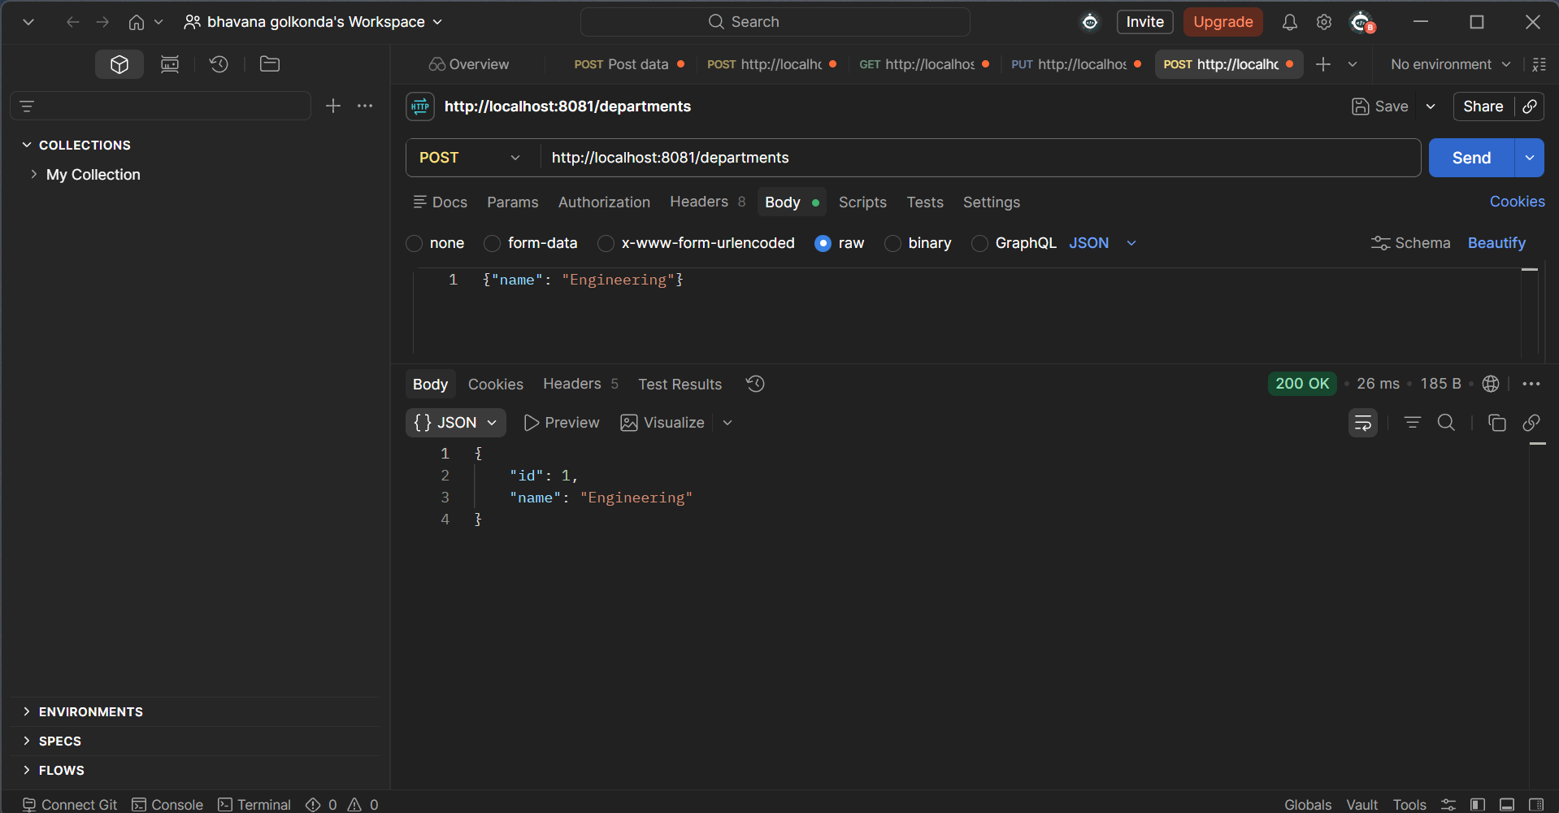

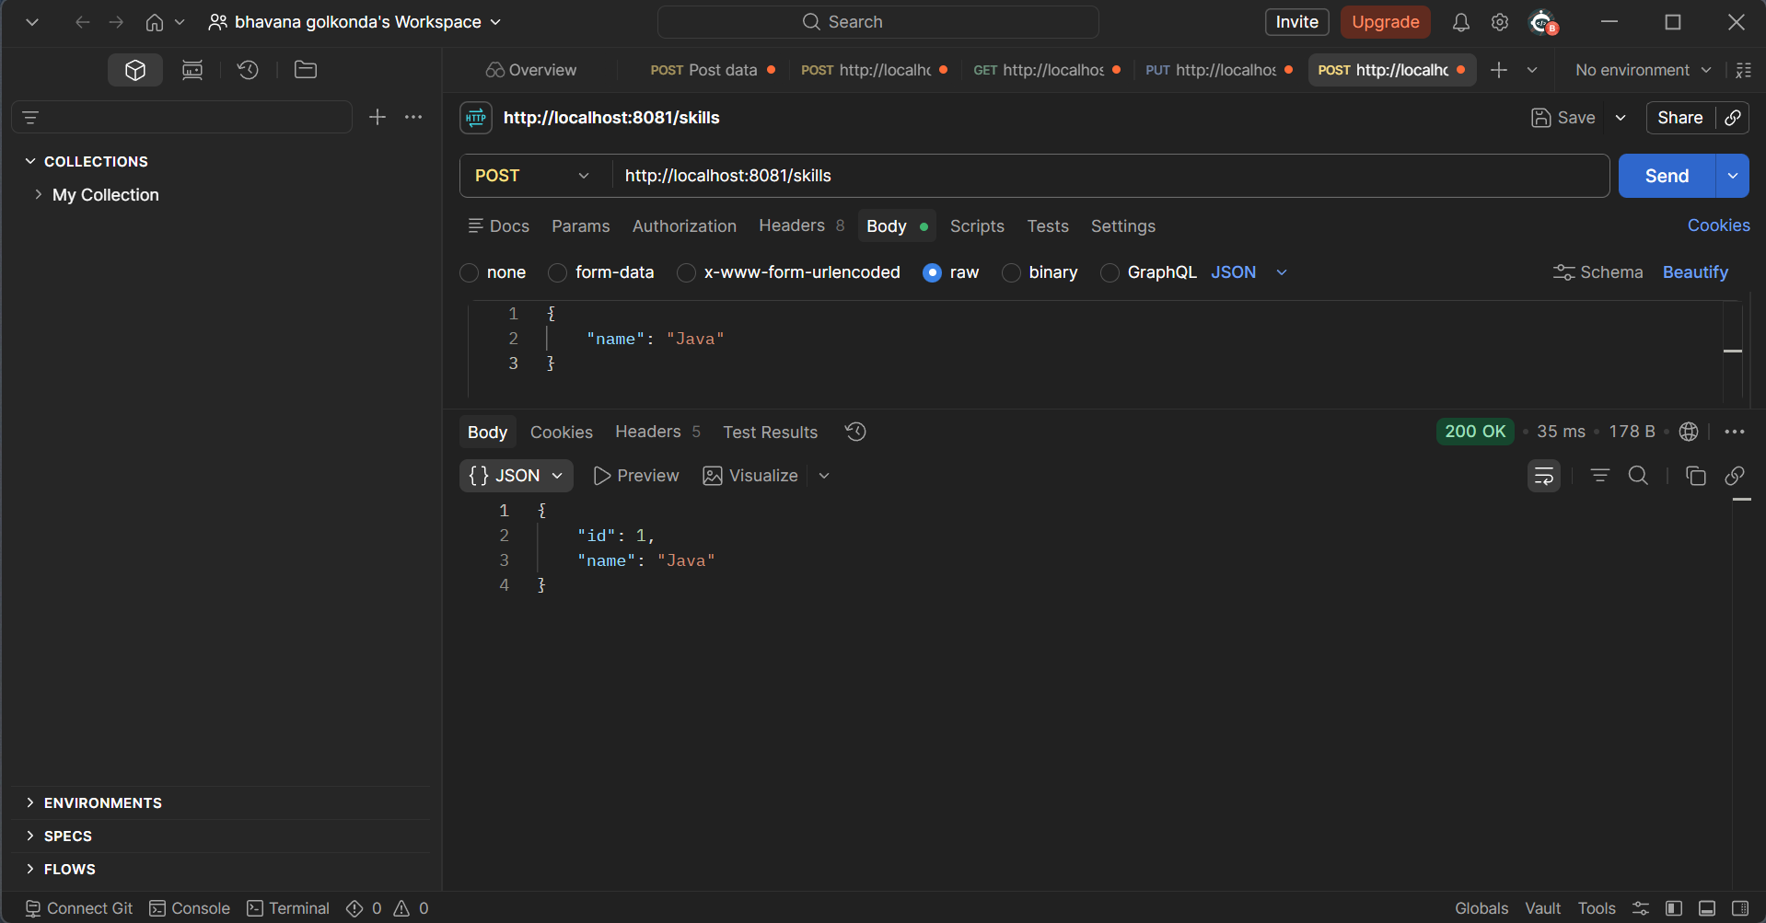

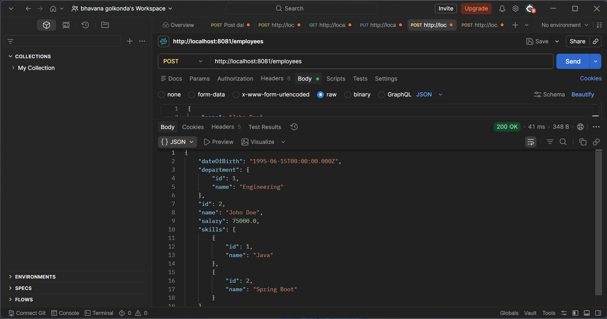

Get All Permanent Employees (with department & skill list)

@Repository
public interface EmployeeRepository extends JpaRepository<Employee, Integer> {
@Query("SELECT e FROM Employee e LEFT JOIN FETCH e.department d LEFT JOIN FETCH e.skillList WHERE e.permanent = 1")
List<Employee> getAllPermanentEmployees();
}

Get Average Salary of a Department

@Query("SELECT AVG(e.salary) FROM Employee e WHERE e.department.id = :id")
double getAverageSalary(@Param("id") int departmentId);

Native SQL Query Example

Get All Employees

@Query(value = "SELECT * FROM employee", nativeQuery = true)
List<Employee> getAllEmployeesNative();

